# [**Dramatic Exits, a Marathon Run and That Sound Explained: 30 Surprising Secrets About Law & Order**](https://www.eonline.com/news/1186206/dramatic-exits-a-marathon-run-and-that-sound-explained-30-surprising-secrets-about-law-order?content=organic&source=twitter-enews&medium=link-post&cmpid=social&s=09)

## For 20 seasons, the original *Law & Order* on NBC steadily became the background of our lives. A look inside one of the most rerun-worthy shows ever made.

**By** [**NATALIE FINN**](https://www.eonline.com/authors/natalie-finn) **SEP 13, 2020 8:00 AMTAGS**

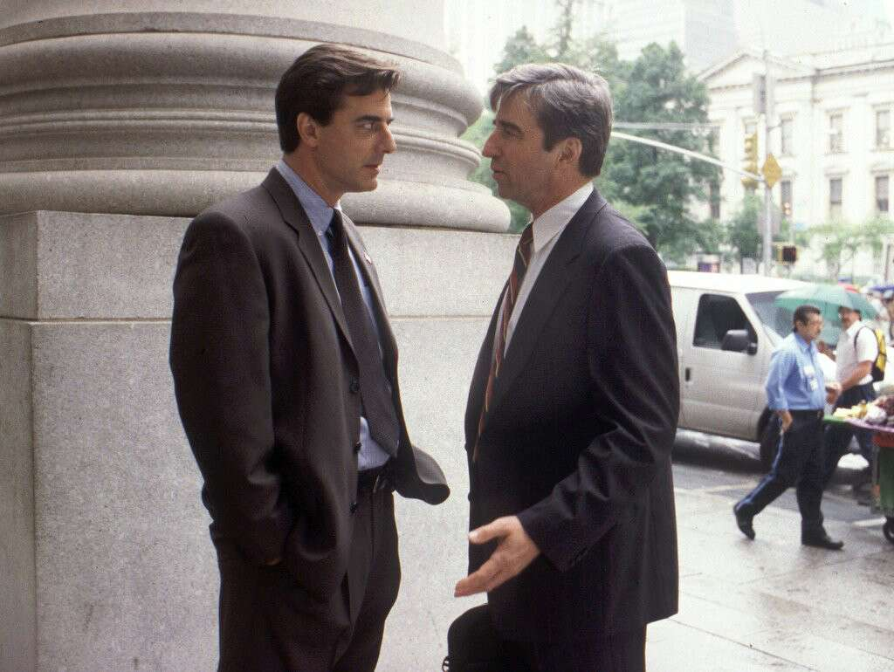NBC

*Chung*-chung.

There are many takes on the spelling of the signature noise that accompanies the jump from scene to scene in an episode of *Law & Order.* Original series star **Dann Florek**, for instance, dubbed it the "doink doink." What isn't in dispute is that the unmistakable clanging, which evokes the slamming of a jail cell door, the justice system at work, is recognizable anywhere thanks to the NBC show, which over the course of 20 seasons steadily became part of the soundtrack of our lives, prolific in references and immortal in reruns.

Psychologists have delved into it at length, so don't worry, there's nothing weird about the fact that *Law & Order—*with all the murder and people doing bad things to each other, and not even *always* being punished for it because the law doesn't always win—is considered comfort TV, a show that's somehow perfect to watch while you're doing the dishes or before bed. Or, you know, just leave one of the many marathons on and go about your day.



[**PHOTOS**](https://www.eonline.com/photos/29022/20-surprising-secrets-about-law-order-svu-revealed)

[**20 Surprising Secrets About *Law & Order: SVU* Revealed**](https://www.eonline.com/photos/29022/20-surprising-secrets-about-law-order-svu-revealed)

Earlier this year, *Law & Order: SVU* was renewed through its 24th season to become the record-smashing crown jewel of the **Dick Wolf** empire. But while *SVU* has its own vibe and its own set of devoted fans who swear by the travails of **Mariska Hargitay**'s Olivia Benson to rock them to sleep at night, in our opinion *Law & Order* remains the more bingeable drama of the two, its crimes a little less heinous, the energy a little peppier and the formula just that much more reliable. (Though if you like your detectives especially quirky, may we direct you to the 10 seasons of *Law & Order: Criminal Intent*.)

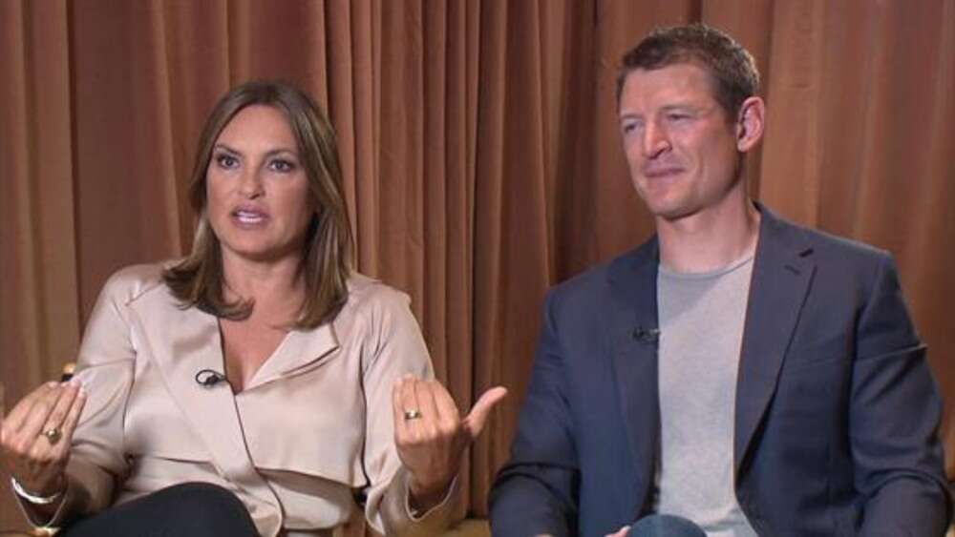

**Related: Mariska Hargitay Reflects on 20 Years of "Law & Order: SVU"**

Testament to its longevity, *Law & Order* premiered 30 years ago today and is airing somewhere right now. But before it was a spin-off-spawning juggernaut and cultural touchstone...

It was just a show. A struggling one-hour drama that multiple networks had passed on, that even NBC wasn't dying to give a pick-up to after 13 episodes. So we've investigated how *Law & Order* went from being just another cop show to the genre-defining prime-time fixture it became. These are its stories:

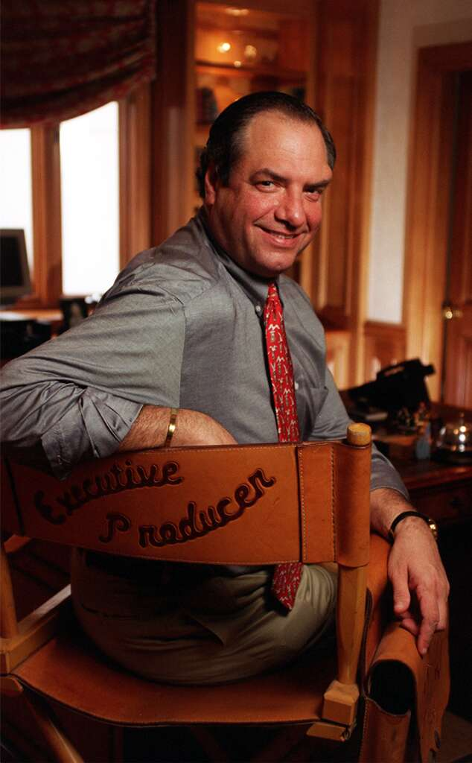Al Seib/Los Angeles Times via Getty Images

**Third Time's a Charm**

After working as an ad man on Madison Avenue and logging time writing for *Hill Street Blues* and *Miami Vice*, **Dick Wolf** pitched his own police-procedural idea (stories ripped from the headlines!) to Fox in 1987, and then-network head **Barry Diller** commissioned 13 episodes—but changed his mind the very next day, calling Wolf to tell him they wouldn't be working together after all. Then CBS bought the pilot—but also didn't order any further episodes. Finally, in 1989, NBC president **Brandon Tartikoff** gave *Law & Order* the greenlight, and it premiered on Sept. 13, 1990.

"We first did it for another network, they passed on it, it kind of was forgotten, and then it was picked up almost by chance," **Dann Florek**, who played Capt. Donald Cragen for the show's first three seasons before departing and returning six years later as the head of the Special Victims Unit, [**recalled on the *Today* show**](https://www.youtube.com/watch?v=ZWdGFHiSKig) in 2015. "But NBC came through."

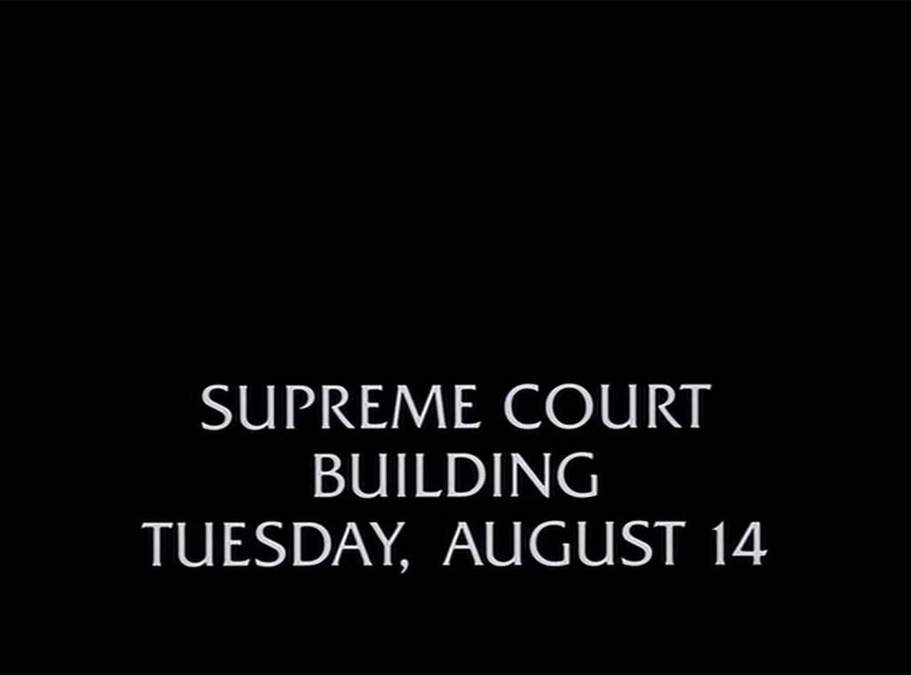NBC

**What's In a Noise**

The *clang-clang* or *chung*-chung or doink-doink was, in fact, inspired by the closing of a jail door. "I think of it as the stylized sound of a jail cell locking," series composer **Mike Post**, who also wrote the iconic theme music, **told *Entertainment Weekly*** in 1993. "I wanted to add something that's very distinctive but not a literal sound. What I tried to do was jar a little bit."

The sound comprises a combination of electronic sound effects, including, according to Post, 500 Japanese men stomping on the floor at once, possibly while in a Kabuki dance class. "They did this whole big stamp," he exclaimed. "Somebody went out and sampled that." Post acknowledged that it was a little odd to him that he'd "written a theme that you think is very musical and what everybody wants to talk about is 'The Clang.'"

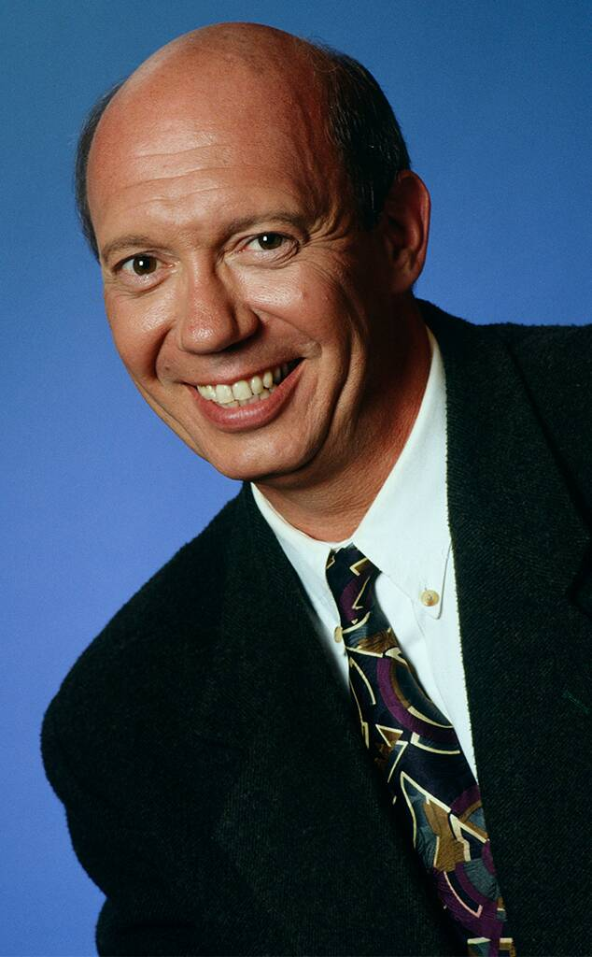Alice S. Hall/NBCU Photo Bank

**Captain Crack-Em-Up**

Florek was apparently quite the cut-up on set. "I don't know where that [rumor] comes from," Florek said as, yes, a fart noise rang out during a *Today* reunion with several co-stars in 2015.

[by Taboola](https://popup.taboola.com/en/?template=colorbox&utm_source=eonline-eonline&utm_medium=referral&utm_content=thumbs-feed-01-mid-article-v2:Mid%20Article%20Thumbnail%20Vertical%20Gallery%20Widget:)

[Sponsored](https://popup.taboola.com/en/?template=colorbox&utm_source=eonline-eonline&utm_medium=referral&utm_content=thumbs-feed-01-mid-article-v2:Mid%20Article%20Thumbnail%20Vertical%20Gallery%20Widget:)

[**These Rare Twins Are All Grown Up, Years Later They Look UnrecognizableOceandraw**](https://rfvtgb.oceandraw.com/worldwide/twins-passed-siblings-ta?utm_campaign=t-od-twins-s-d-ww-250920&utm_medium=taboola&utm_source=taboola&utm_term=eonline-eonline)

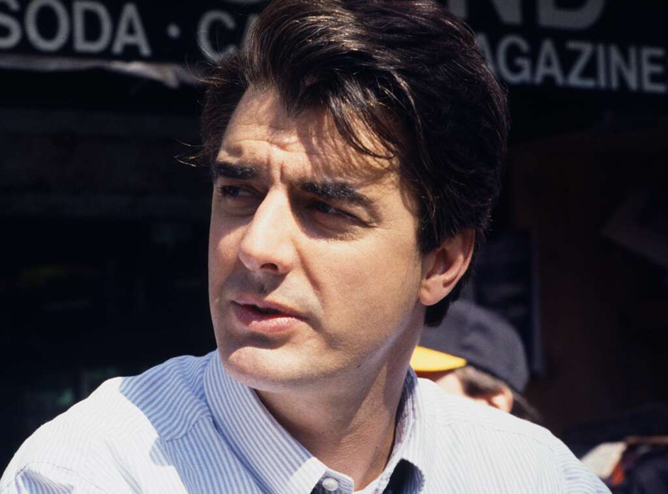Jessica Burstein/NBCU Photo Bank

**Mr. Research**

While playing Detective Mike Logan, original series star **Chris Noth** would hang out with actual detectives. On an excursion to a missing woman's apartment with investigators from the NYPD's 34th Precinct, one of the real cops on the call caught a whiff of Pine Sol. It turned out that the woman's body was in the apartment, Noth recalled to the *New York Times*, and "the detective smelled death."

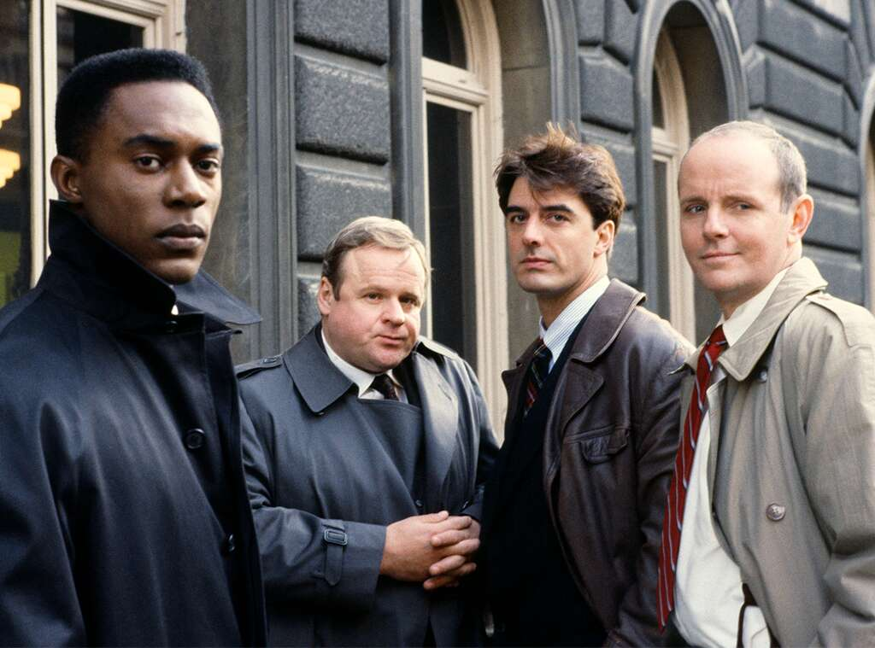NBCU Photo Bank

**One and Done**

Max Greevey, Logan's first partner who was played by **George Dzundza**, was shot dead off camera in the season-two premiere—because Dzundza signed on to *L&O* when it was originally supposed to film in Los Angeles. After finding out they were staying put in New York, the *Dangerous Minds* actor left the show after only one season, not wanting to move his family cross country.

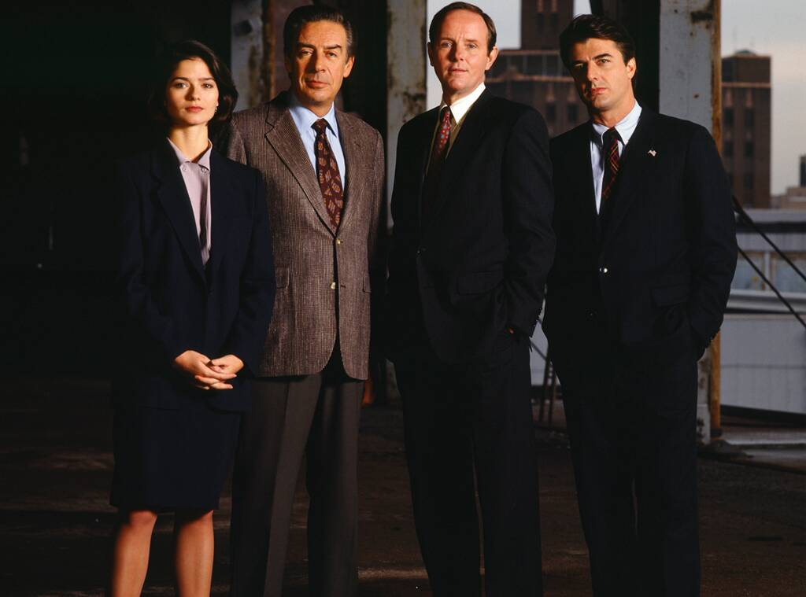NBCU Photo Bank

**Going Co-Ed**

*L&O*, which in 2009-10 tied *Gunsmoke* for the longest-running live-action TV series ever in prime-time with 20 seasons (since surpassed by *Law & Order: SVU*) barely made it past season three. In 1993, NBC President **Warren Littlefield** told Wolf he had six months to figure out how to give the moderately rated show (44th in prime time the week of March 1, 1992) a jolt that would attract a bigger audience.

Littlefield's advice, as he [**remembered it to *Forbes***](https://www.forbes.com/sites/dawnchmielewski/2020/07/24/how-law--orders-dick-wolf-is-reimagining-his-shows-in-the-wake-of-the-blm-protests/#46f5869556a7) recently: "Let's make it less of a men's club. You need more women on camera." Enter NYPD Lt. Anita Van Buren, played by **S. Epatha Merkerson**, and **Jill Hennessy** as Assistant District Attorney **Claire Kincaid**, the first in the parade of female ADAs to pair with the always-male Executive Assistant District Attorney, in the fourth-season premiere.

Which meant, however, that **Richard Brooks**—ADA Paul Robinette—was let go, along with Florek. Robinette returned several times over the years, having moved into criminal defense and far more skeptical of the fairness of the justice system than when he was working for the city. Brooks, who in recent years has been on *Being Mary Jane*, *Good Trouble* and *Bosch*, also brought Robinette back for *Chicago Justice* in 2017.

[by Taboola](https://popup.taboola.com/en/?template=colorbox&utm_source=eonline-eonline&utm_medium=referral&utm_content=thumbs-feed-01-mid-article-v2:Mid%20Article%20Thumbnail%201x1%20Vertical%20Gallery%20Widget:)

[Sponsored](https://popup.taboola.com/en/?template=colorbox&utm_source=eonline-eonline&utm_medium=referral&utm_content=thumbs-feed-01-mid-article-v2:Mid%20Article%20Thumbnail%201x1%20Vertical%20Gallery%20Widget:)

[**Fuja dessas SUV! As mais terríveis SUV já produzidasVida Brilhante**](https://www.vidabrilhante.com/curiosidades/listamos-as-suv-que-voce-nunca-deveria-comprar/?utm_source=tb&utm_medium=eonline-eonline-tb&utm_term=Fuja+dessas+SUV%21+As+mais+terr%C3%ADveis+SUV+j%C3%A1+produzidas-https%3A%2F%2Fs3.amazonaws.com%2Fhivemedia-images%2Fcreatives%2Fszu%2Fszu.jpg&utm_content=2925537457&utm_campaign=6139637-tb&utm_source=tb)

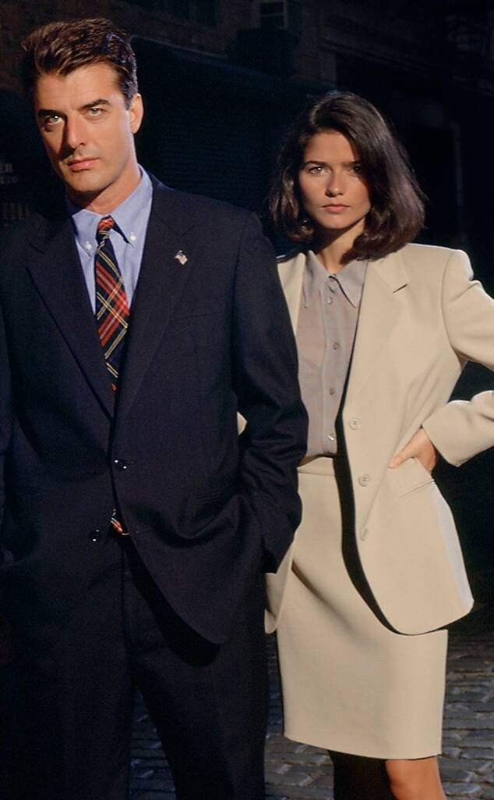NBCU Photo Bank

**A Laughing Matter**

"I won't even subject you to what he did to me on camera," Hennessy, who was 24 when she joined the show, recalled her first days filming with Noth to PeopleTV, "but I was trying not to laugh, trying so hard not to laugh, I'm supposed to be really, really serious. But I held it together, barely, and then the camera had to turn around for his close-up, and then I did that old school yard trick, where you crack an egg on somebody's knee, and it tickles them? It's a serious scene, and he's being tough, and I cracked the egg."

At the time, however, she pleaded not guilty.

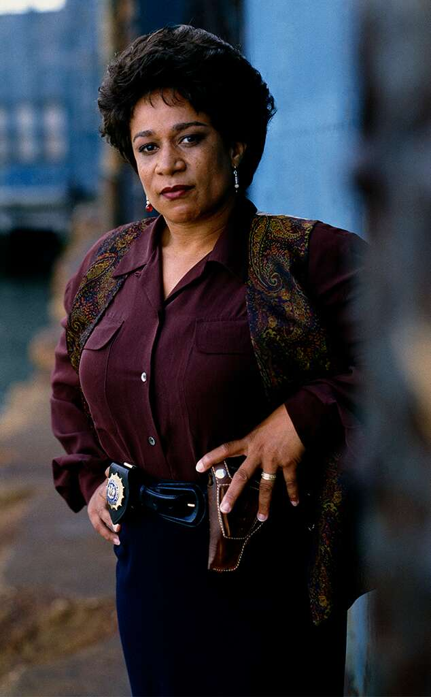NBCU Photo Bank

**Commanding Officer**

Van Buren remained the boss at the 27th Precinct until the end, becoming the show's longest-running character. "One of the things I love most is that my voice is heard," Merkerson reflected during a [**2009 sit-down at the Paley Center**](https://www.youtube.com/watch?v=YTZlQYqOT6A). The actress explained, "Sometimes I win, most times I lose—but sometimes I win. Really, the point is, is that I come from a specific background. I'm Black, I'm female and I'm in my 50s. There's no one who sits at our table who sits from my perspective." So, she continued, "when I see my argument onscreen, it's an amazing feeling to know that you're a part of something, and it has been one of the reasons why I have enjoyed being on this show, is having a voice and being a real integral part of the show."

The Emmy winner (for *Lackawanna Blues* in 2005) remains in the Wolf universe, playing hospital administrator Sharon Goodwin on *Chicago Med*, but Merkerson knows why she's a legend.

"There will be kids that'll walk up to me and say, you know, 'I watched your show through college,' and they're, like, in their 30s," she marveled on the *Today* show in 2015. Replied co-host **Jenna Bush Hager**, "Well, I watched your show through college. Thank you for getting me through it!"

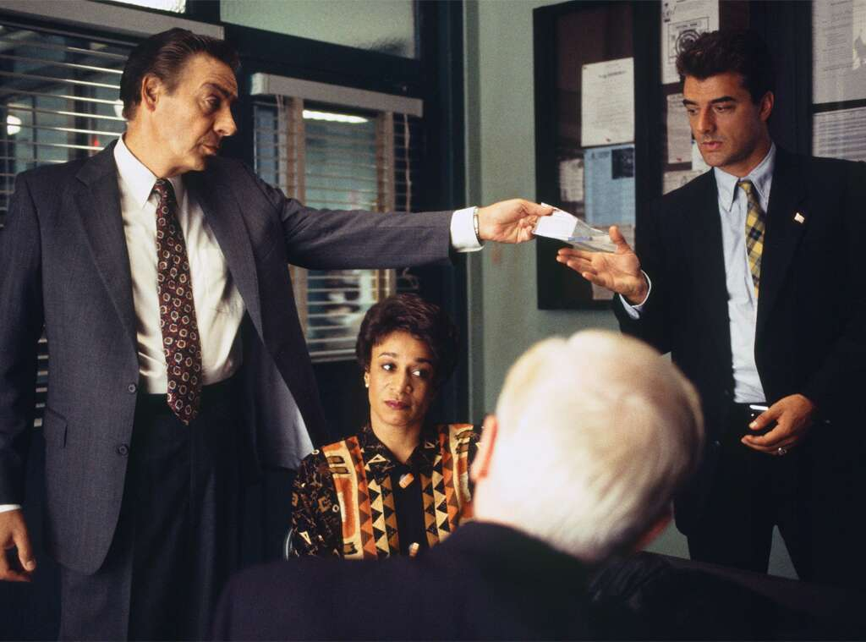NBCU Photo Bank

**A Real Good Fella**

According to Dick Wolf, Warren Littlefield had real reservations about **Jerry Orbach** joining the show as a detective in season four, to replace the departing **Paul Sorvino** (who had replaced Dzundza), because the veteran actor and Broadway star's own show on CBS—a *Murder, She Wrote* spin-off called *The Law and Harry McGraw*—had flopped.

"Warren got very upset and said, 'You know, this is ridiculous,'" Wolf [**told *The Hollywood Reporter***](https://www.hollywoodreporter.com/news/tv-producer-year-dick-wolf-794537)in 2015. "I said, 'No, no, no. It's no problem.'" But Littlefield said, "'Over my dead body.' I said, 'Warren, die.'"

Of course Detective Lennie Briscoe became a fan favorite, walking the beat for 12 seasons until Orbach left the show in 2004. At first he was going to be a regular on the spin-off *Law & Order: Trial by Jury*, but he died that December after a 10-year battle with prostate cancer. He was posthumously honored with the SAG Award for Outstanding Male Actor in a Drama Series in 2005.

[by Taboola](https://popup.taboola.com/en/?template=colorbox&utm_source=eonline-eonline&utm_medium=referral&utm_content=thumbs-feed-01-mid-article-v2:Mid%20Article%20Thumbnail%201x1%20Vertical%20Gallery%20Widget%202:)

[Sponsored](https://popup.taboola.com/en/?template=colorbox&utm_source=eonline-eonline&utm_medium=referral&utm_content=thumbs-feed-01-mid-article-v2:Mid%20Article%20Thumbnail%201x1%20Vertical%20Gallery%20Widget%202:)

[**Sem anúncios, sempre.Deezer**](https://www.deezer.com/offers/premium?origin=acq_Taboola&utm_campaign=acq_BR-PT_Premium-09-2020-Affiliates_WEB_Taboola_Performance_TBCC&utm_content=offers-premium&utm_medium=native-obj_sub&utm_source=Taboola&tblci=GiBHeQG4zAqUVOo8tj4Ps8qtomul9ST0mpidxEr49RzSmCDOhlE#tblciGiBHeQG4zAqUVOo8tj4Ps8qtomul9ST0mpidxEr49RzSmCDOhlE)

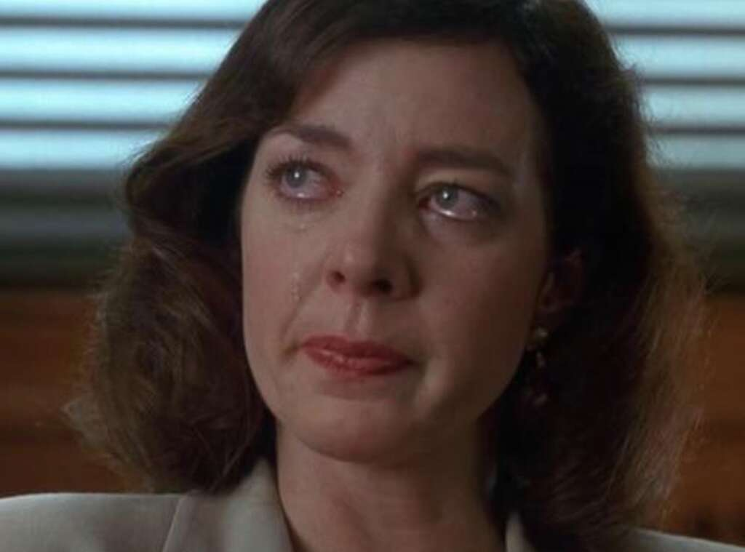NBC

**Stone Cold**

The exit of **Michael Moriarty**'s EADA Ben Stone was memorable, the guilt-stricken prosecutor handing in his resignation after his reluctant star witness (**Allison Janney**, playing her second character in as many appearances) is gunned down by the Russian mob. But Moriarty's reason for leaving the show is no less dramatic. He chose to go—loudly and proudly—in protest after then-U.S. Attorney General **Janet Reno** endorsed the idea of legislation to curb what can be shown on television, giving credence to the theory that violence on TV contributed to an uptick in real-world crime. Wolf, several NBC executives and Moriarty met with Reno in the fall of 1993, and the actor was outraged by the AG's stance—as well as by what he saw as his colleagues' refusal (at NBC and all over Hollywood) to speak up against censorship. Moriarty was subsequently written out of the show at the end of season four.

"Television executives know that this is wrong, but they would lose their job if they went head-to-head with the federal government," Moriarty told the [***Los Angeles Times***](https://www.latimes.com/archives/la-xpm-1994-03-06-op-30500-story.html) in May 1994, at the time headed to Broadway to play Professor Higgins in *My Fair Lady*. "I have the freedom to say, screw it. I can do a little piano here, write books there, whatever. I am not going to give up my personal freedom and self-respect for a career."

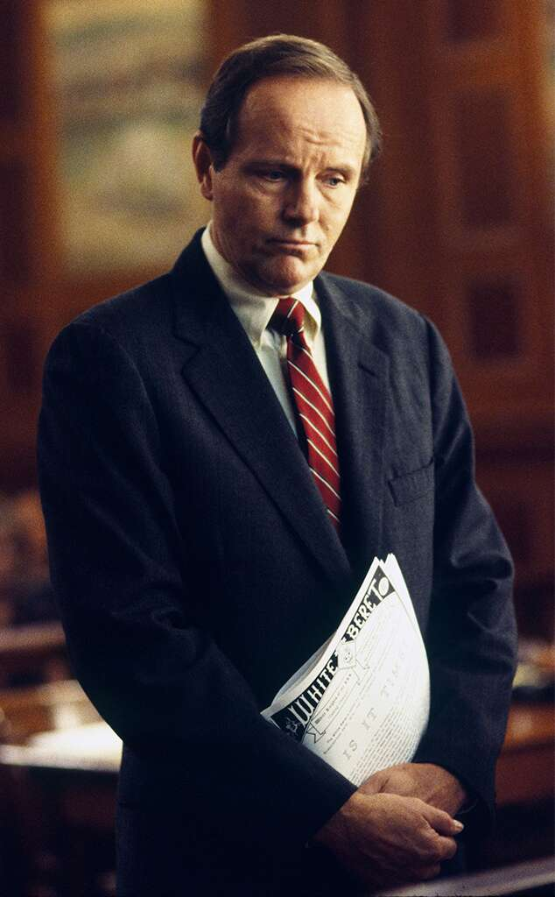Gerry Goodstein/NBCU Photo Bank

He continued to appear in films such as *Courage Under Fire* and *Along Came a Spider*, and won an Emmy playing the father of **James Franco**'s *James Dean* in the 2001 TV biopic, but he remains best known for his *Law & Order* days. Over the years, the narrative got hazy as to whether Moriarty quit or was fired—but he's quick to share his side.

"In early 1994, I quit *Law and Order* and announced my departure in the Hollywood Reporter and Daily Variety," the actor recalled to [***Cinema Retro***](https://cinemaretro.com/index.php?/archives/6032-WHATEVER-HAPPENED-TO-MICHAEL-MORIARTY.html) in 2011. "My employers, the mainstream press and even Wikipedia like to say that it was Dick Wolf who fired me and not the other way 'round. People say, 'Oh, well, no one fires Dick Wolf!' Well, I did. At any rate, I had become an American dissident. I left for Canada not too long after that."

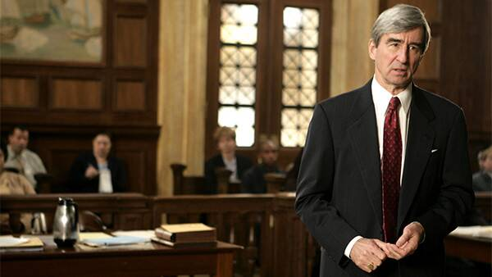NBC

**The Real McCoy**

Wolf recalled the Moriarty exit drama to [***The Hollywood Reporter***](https://www.hollywoodreporter.com/news/tv-producer-year-dick-wolf-794537) in 2015. "The fax came in the middle of the night to California, which means that he'd been up all night [in NY]," the producer remembered. "It was like, 'I can't continue.' It was things like the 'Nazification of television' and everything else with Janet Reno. Warren called me at home, which never happened, at 7 a.m. He said, 'Did you get this?' I said, 'Of course I got it.' He said, 'What are we going to do? He's the moral heart of the show. There's no way we can work around this.' I said, 'Sure there is. I've got two words for you: **Sam Waterston**.'"

So began Waterston's legendary run as EADA (and later DA) Jack McCoy, which lasted until the show signed off in 2010. "I'm an actor because I didn't get cast as Cyrano [de Bergerac]" in a prep school production, the Emmy-nominated actor shared in a [**2008 sit-down**](https://www.youtube.com/watch?v=zDCAEgCZoBg) with the Forum on Law, Culture & Society. "I wanted it really badly." As for the student who did get the part, "he became a lawyer!"

Waterston, who played McCoy for 16 seasons, also acknowledged the show's lasting impact, saying, "Unless they're lying, I know there must be at least 20 or 30 people who have become lawyers because of *Law & Order*, because they've told me so." He quipped, "I've had to apologize time and time again. 'Oh, I'm a lawyer because of you.' 'Oh, I'm sorry.'"

[by Taboola](https://popup.taboola.com/en/?template=colorbox&utm_source=eonline-eonline&utm_medium=referral&utm_content=thumbs-feed-01-mid-article-v2:Mid%20Article%20Thumbnail%201x1%20Vertical%20Gallery%20Widget%203:)

[Sponsored](https://popup.taboola.com/en/?template=colorbox&utm_source=eonline-eonline&utm_medium=referral&utm_content=thumbs-feed-01-mid-article-v2:Mid%20Article%20Thumbnail%201x1%20Vertical%20Gallery%20Widget%203:)

[**Ray-Ban Aviador Original por R$249,90 + frete grátisOculos Now**](https://www.oculosnow.com/ray-ban-aviador-preto-preto-rb3025/p?utm_medium=CPC&utm_source=TABOOLA_DESKTOP_ABERTO&tblci=GiBHeQG4zAqUVOo8tj4Ps8qtomul9ST0mpidxEr49RzSmCDNu04#tblciGiBHeQG4zAqUVOo8tj4Ps8qtomul9ST0mpidxEr49RzSmCDNu04)

NBC

**Logan's Run**

Noth left after five seasons because his contract was up and, Wolf acknowledged, he was due a huge pay raise and they just weren't going to be able to swing that "due to the age of the show." The series creator [**told the AP**](https://apnews.com/eedd22da858b48ce94b8a6895ea9bdaf) in 1995, "I want to emphasize that Chris has done a spectacular job this year. He's never been better."

A rep for Noth said the actor was sorry it didn't work out, but he'd had five great years and was off to pursue a movie career (while on the show, Logan slugged a councilman—who really was a creep—and ended up marooned on Staten Island). Movie stardom wasn't in the cards, but the actor became Mr. Big when *Sex and the City* premiered three years later.

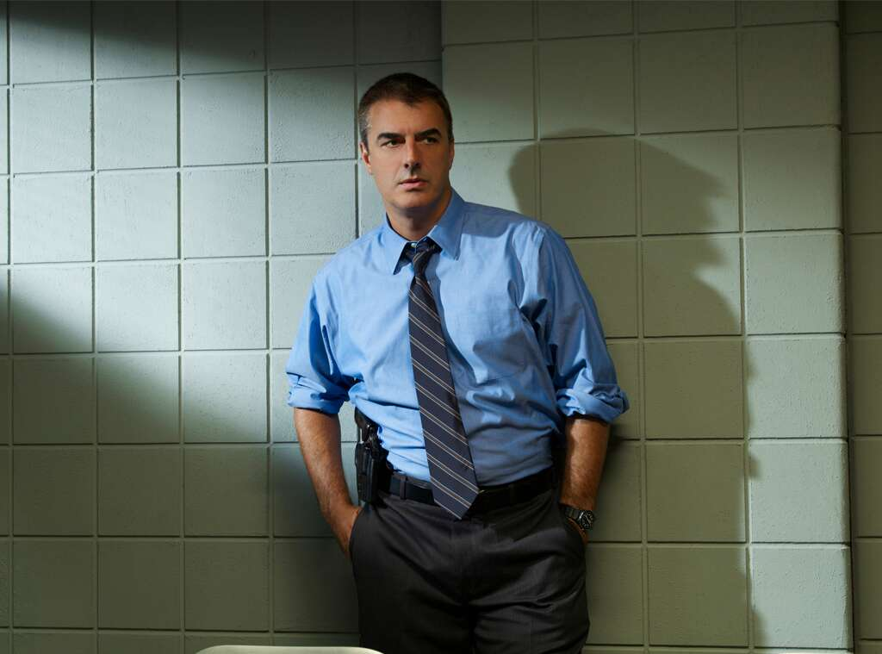Eric Ogden/USA/NBCU Photo Bank

And there really were no hard feelings, as Noth returned as Logan for the 1998 TV movie *Exiled* and then joined the cast of *Law & Order: Criminal Intent* in 2005 after *SATC* ended.

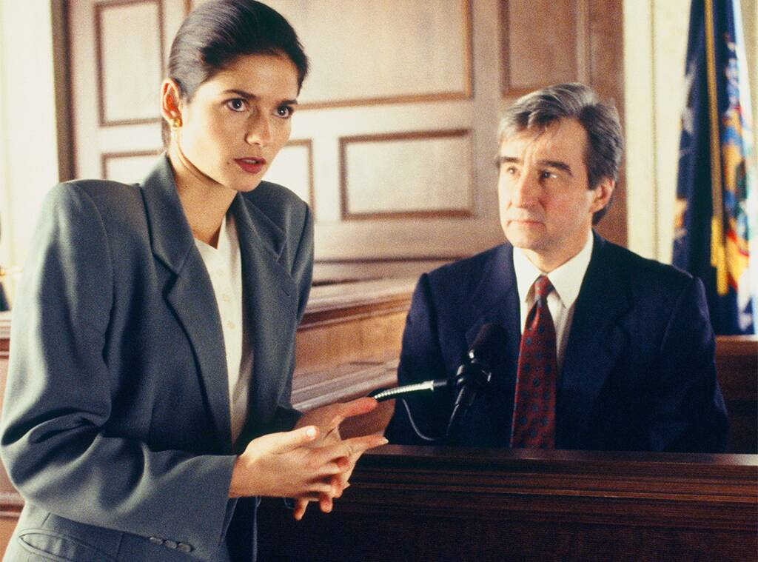NBCU Photo Bank

**Postscript**

"That was kind of disturbing actually," Hennessy admitted in a [**2018 interview on Q104.3 New York**](https://www.youtube.com/watch?v=0W8jGxwV0xk), reflecting on the episode revealing the death of Claire Kincaid, the former A.D.A. killed in a car accident at the end of season six (though her demise isn't spelled out until several seasons later). An episode which, like so many other people, the *City on a Hill* star accidentally started watching in the middle of the night while a *Law & Order* marathon was on.

Asked how much notice she got that she was going to be killed off, Hennessy recalled, "Not much!" She laughed. "Sometimes people get no advance. I can't even remember what I heard there. I think I just knew when we got the script." In her case, at least, she was told what was coming before she started reading. "I've heard of other actors who literally discovered as they were reading the script, so…it's a rude awakening."

Apparently, the original idea was have Claire emerge paralyzed from the accident and then leave the D.A.'s Office for private practice, but Hennessy denied in 2010 to *TV Guide* that it wasn't she who was unwilling to return for a formal goodbye. "I made it clear I wanted to come back," she said. "I found out they killed me off from a friend who watched the show and told me, 'Jill, they said you were dead!' I was surprised, because I always thought I would return. Even now, I'd love to come back for some bizarre flashbacks."

[by Taboola](https://popup.taboola.com/en/?template=colorbox&utm_source=eonline-eonline&utm_medium=referral&utm_content=thumbs-feed-01-mid-article-v2:Mid%20Article%20Thumbnail%201x1%20Vertical%20Gallery%20Widget%204:)

[Sponsored](https://popup.taboola.com/en/?template=colorbox&utm_source=eonline-eonline&utm_medium=referral&utm_content=thumbs-feed-01-mid-article-v2:Mid%20Article%20Thumbnail%201x1%20Vertical%20Gallery%20Widget%204:)

[**Top 10 carros que se deram mal no mercadoTG Centro Automotivo**](https://pt.tgcentroautomotivo.com.br/top-10-carros-que-se-deram-mal-no-mercado/?utm_source=TaboolaDesktopTGPTTop10CarrosQueSeDeramMal&utm_medium=eonline-eonline&utm_campaign=Top+10+carros+que+se+deram+mal+no+mercado&utm_term=http%3A%2F%2Fcdn.taboola.com%2Flibtrc%2Fstatic%2Fthumbnails%2F93d1e3aa205bd50bc165bead98e7f01e.jpg&utm_content=6082876#tblciGiBHeQG4zAqUVOo8tj4Ps8qtomul9ST0mpidxEr49RzSmCDu0Uc)

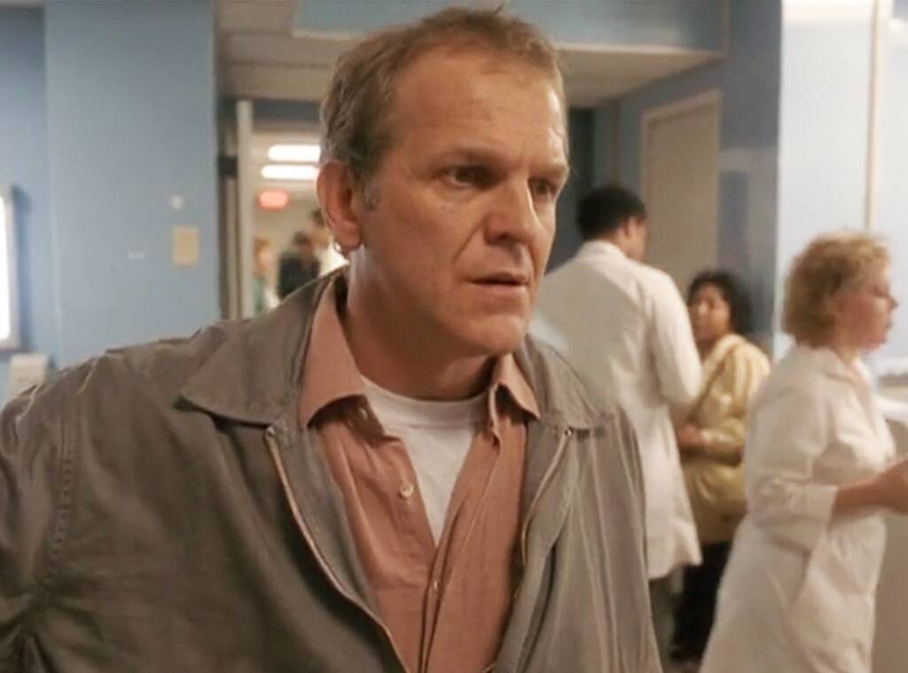NBCU

**From Day One**

There's a long-running joke about every New York actor having pulled *L&O* duty at some point in his or her career, and the list of both before-they-were-famous and wow-it's-Julia-Roberts-famous cameos is indeed extensive. In fact, the series premiere, "Prescription for Death" (not to be confused with the pilot, "Everybody's Favorite Bagman," which was produced in 1988 and aired as episode six of season one) features **John Spencer**, who had been on *L.A. Law* but would cement his place in pop culture history playing Leo McGarry on *The West Wing*, playing a distraught dad whose daughter ends up dead after a hospital visit for an ailment that didn't seem all that serious.

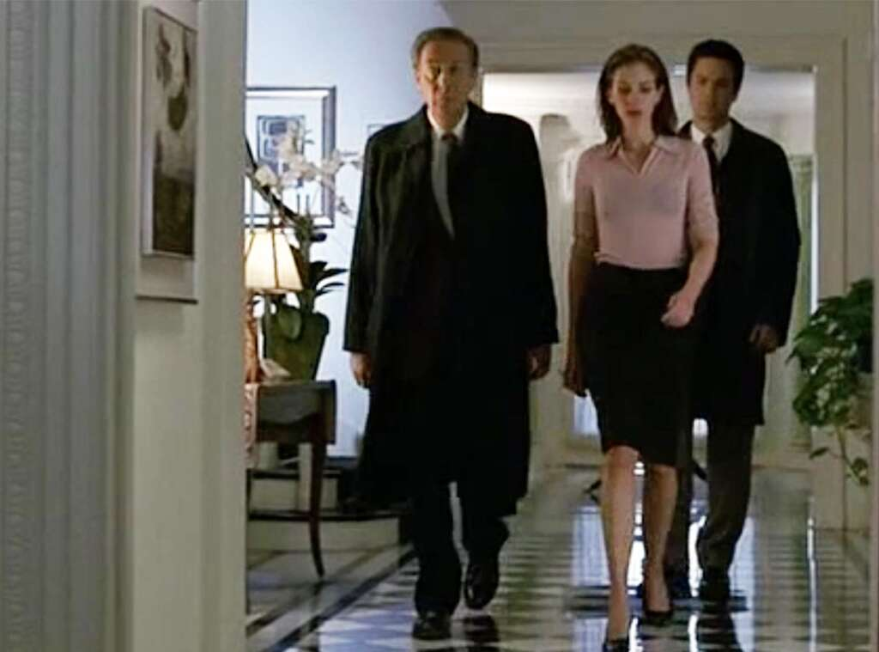NBC

**Pretty Witness**

Speaking of which, **Julia Roberts** appeared on the show in 1999 while she was dating **Benjamin Bratt**, who played Det. Rey Curtis for four seasons. Roberts was nominated for an Emmy for outstanding performance by a guest actress in a drama series.

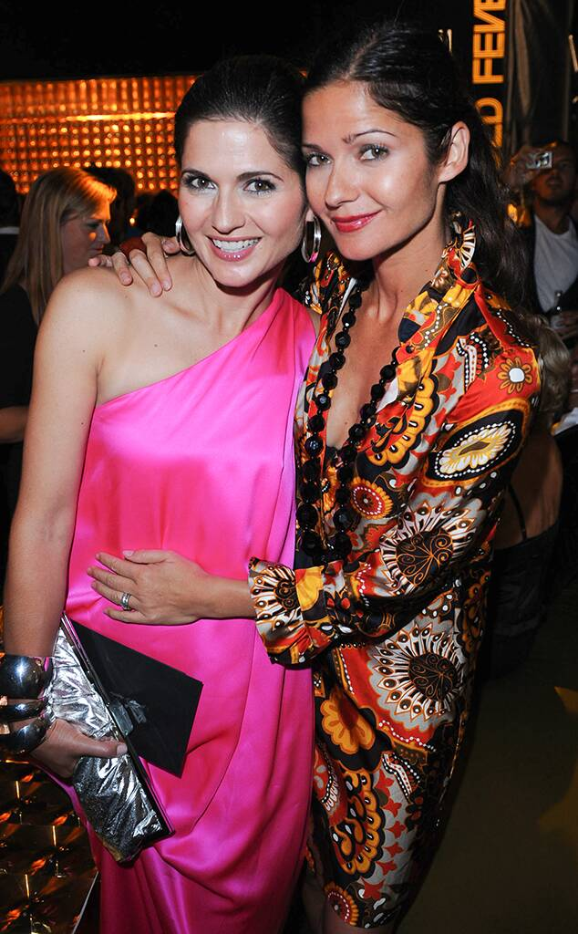George Pimentel/WireImage

**Sneaky Sister Act**

In season six, episode 12, "Corpus Delicti," Hennessy's twin sister, **Jacqueline Hennessy**, stood in as Claire Kincaid in some courtroom scenes because Jill was busy playing Claire in Baltimore, for a *Law & Order*-*Homicide: Life on the Street* crossover event.

[by Taboola](https://popup.taboola.com/en/?template=colorbox&utm_source=eonline-eonline&utm_medium=referral&utm_content=thumbs-feed-01-mid-article-v2:Mid%20Article%20Thumbnail%201x1%20Vertical%20Gallery%20Widget%205:)

[Sponsored](https://popup.taboola.com/en/?template=colorbox&utm_source=eonline-eonline&utm_medium=referral&utm_content=thumbs-feed-01-mid-article-v2:Mid%20Article%20Thumbnail%201x1%20Vertical%20Gallery%20Widget%205:)

[**Imecap Hair Max, seu melhor você. Antiqueda+força+brilhoImecap**](https://imecaphair.com.br/?utm_campaign=nbs_nacional_imacap_hair_max_2sem_taboola_display_cons_divcom_imecap&utm_source=taboola&utm_medium=display&utm_content=seu_melhor_voce_native-Ad_cpc_0s_custom-intent_seumelhorvoce&utm_term=site-home&tblci=GiBHeQG4zAqUVOo8tj4Ps8qtomul9ST0mpidxEr49RzSmCCznk8#tblciGiBHeQG4zAqUVOo8tj4Ps8qtomul9ST0mpidxEr49RzSmCCznk8)

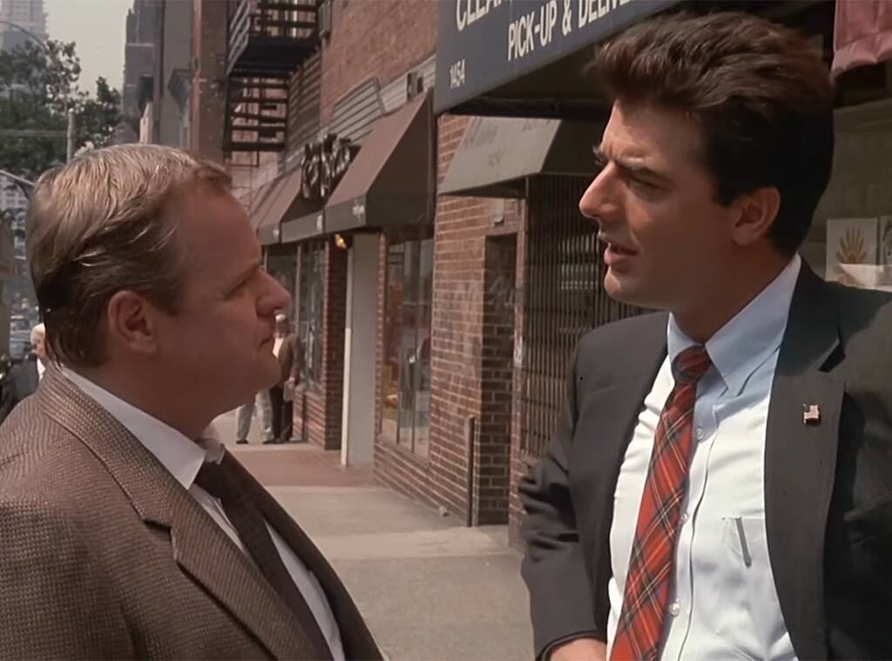NBC

**Early Controversy**

The 12th episode of season one, called "Life Choice," focused on the bombing of an abortion clinic that left an anti-abortion activist dead—a case that Greevey is ambivalent about because he thinks abortion is wrong, while Logan says he's firmly pro-choice and that his ex-girlfriend had the procedure and went on to become a happily married (to someone else) mother of two. It turned out the victim was pregnant and was at the clinic to have an abortion, despite her outward stance. "On the abortion episode, there were $900,000 in advertiser pull-outs," Wolf told *THR* in 2015. "Brandon [Tartikoff] didn't care. It was a good show."

In taking on a subject that was generally considered too taboo for television, "Life Choice" ranked 68th on *TV Guide*'s 2009 list of the [**100 Greatest Episodes of All-Time**](https://web.archive.org/web/20120520034436/http://www.imdb.com/list/mDwYpIpc8m8/).

They also took on the hot-button issue in 1995 and again 2009 in episodes featuring the killing of doctors, the latter inspired by the May 2009 murder of late-term abortion provider Dr. George Tiller at his Kansas church. In that case, EADA Michael Cutter (**Linus Roache**) expresses anti-abortion beliefs and ADA Connie Rubirosa (**Alana De La Garza**) is pro-choice.

"For 20 seasons the Emmy-winning *Law & Order* has explored a variety of controversial topics, and the episode 'Dignity' does just that," NBC and producers said in a statement. "Viewers will see a balanced, thought-provoking drama about abortion." And all the advertising spots for the timeslot remained sold, a network executive told the [***New York Times***](https://www.nytimes.com/2009/10/23/arts/television/23abort.html) before the episode aired.

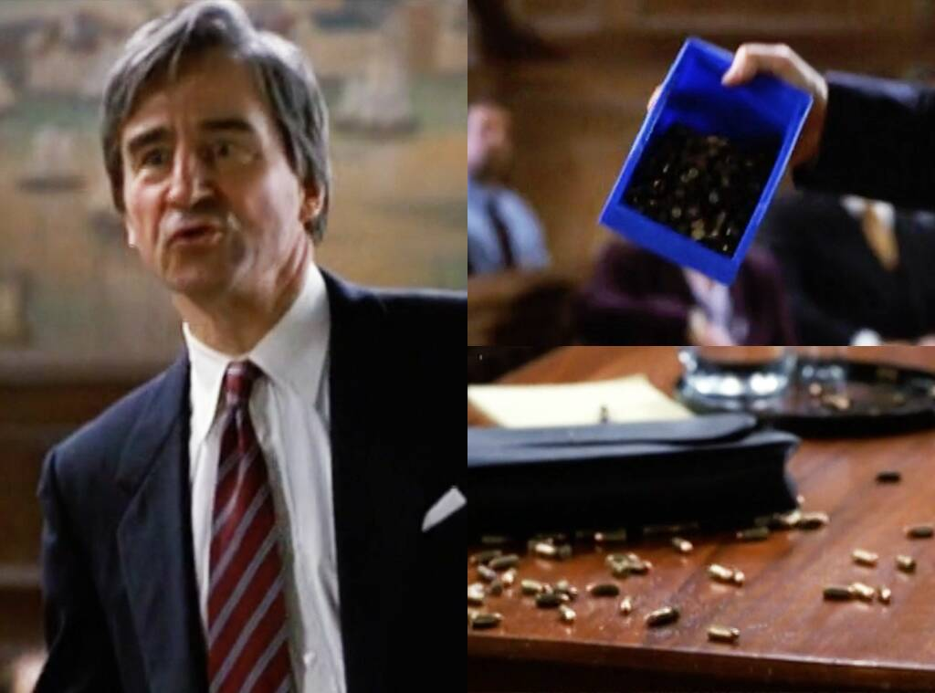NBC

**Putting Politics Aside**

While most cop shows (including *Law & Order: SVU*, *Chicago PD* and *FBI*) are under renewed scrutiny these days for the ways in which they tend to glorify how law enforcement and the criminal justice system work, Wolf felt in its day that *Law & Order* was a show that was fair in how it portrayed the police and prosecutors. "You'd have a hard time finding anybody who associated with this show who would identify himself as a conservative Republican," Wolf [**told the *New York Times***](https://www.nytimes.com/1992/03/01/arts/television-dick-wolf-breaks-and-enters-with-law-and-order-on-nbc.html) in 1992. "But we have an accurate depiction of law enforcement's professional attitudes. There are no atheists in foxholes, and there are very few liberals in the district attorney's office."

Actually, all sorts of views co-existed in the show and sometimes within a single character—such as when Jack McCoy, never one to not at least explore the possibility of seeking the death penalty when possible, goes after a gun manufacturer for murder after a mass shooting, dramatically pouring a bucket full of bullets onto the prosecution's table (and wins a conviction, only to have the verdict set aside by the trial judge right then and there).

Asked if there was a particular episode that challenged his own thinking, Waterston said in 2009 that any episode involving the death penalty challenged him "because I thought differently than my character."

And Wolf told the *Times* that, when the script called for Ben Stone to say, "In the criminal justice system, if it's legal, it's ethical," Moriarty "almost choked on that line."

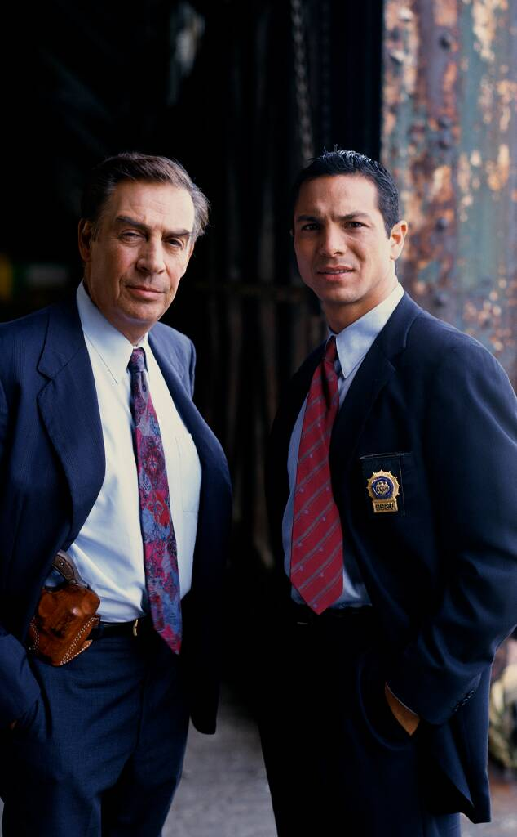NBCU Photo Bank

**Academy Commendations**

*Law & Order* was nominated for 51 Emmys over the years, winning seven, including Best Drama Series in 1997. Only five full-time cast members in that whole span were nominated for acting Emmys, though Michael Moriarty was nominated four times, for every season he was in. The others included Sam Waterston (three times), **Steven Hill** (twice) Jerry Orbach (once), and Benjamin Bratt (once).

[by Taboola](https://popup.taboola.com/en/?template=colorbox&utm_source=eonline-eonline&utm_medium=referral&utm_content=thumbs-feed-01-mid-article-v2:Mid%20Article%20Thumbnail%201x1%20Vertical%20Gallery%20Widget%206:)

[Sponsored](https://popup.taboola.com/en/?template=colorbox&utm_source=eonline-eonline&utm_medium=referral&utm_content=thumbs-feed-01-mid-article-v2:Mid%20Article%20Thumbnail%201x1%20Vertical%20Gallery%20Widget%206:)

[**Greatest Footballers of All Time by CountryStadium Talk**](https://www.stadiumtalk.com/s/best-soccer-player-ever-by-country-1fe7a6d966464532?utm_campaign=soccerbycountry-761782b7ab3e4bd4&utm_source=tab&utm_medium=cpc&utm_term=eonline-eonline)

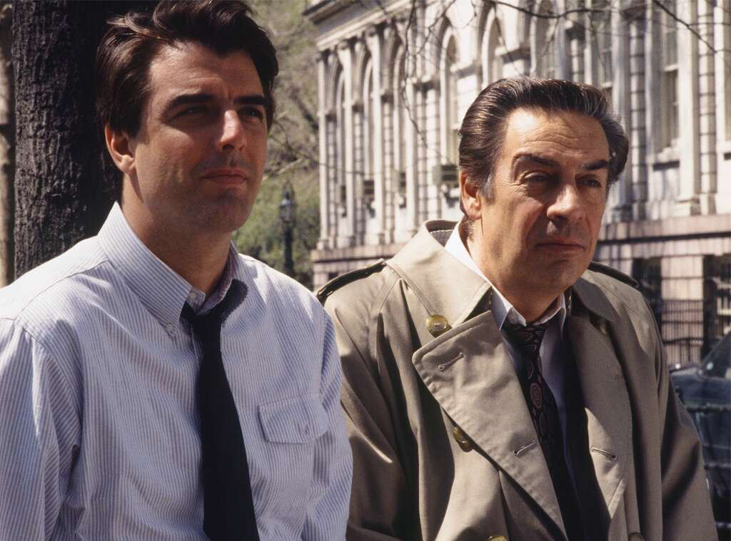Jessica Burstein/NBCU Photo Bank

**Hometown Team**

When it began, *Law & Order* was the only network TV drama shot entirely in New York City. "You get glimpses of the buildings through windows," **Joseph Stern**, at the time one of the show's executive producers, [**told the *New York Times***](https://www.nytimes.com/1992/03/01/arts/television-dick-wolf-breaks-and-enters-with-law-and-order-on-nbc.html) in 1992. "And you know you can't be anyplace else. And you're always hearing the city. The traffic. The voices. The cops have a New York accent."

And it remained a quintessentially New York show throughout. Asked in 2008 if there was anywhere in the city he hadn't filmed, **Jesse L. Martin** [**told EW.com**](https://ew.com/article/2008/02/21/jesse-martin-on/), "I don't even know, but I don't think so. We've literally been everywhere. I mean, everywhere."

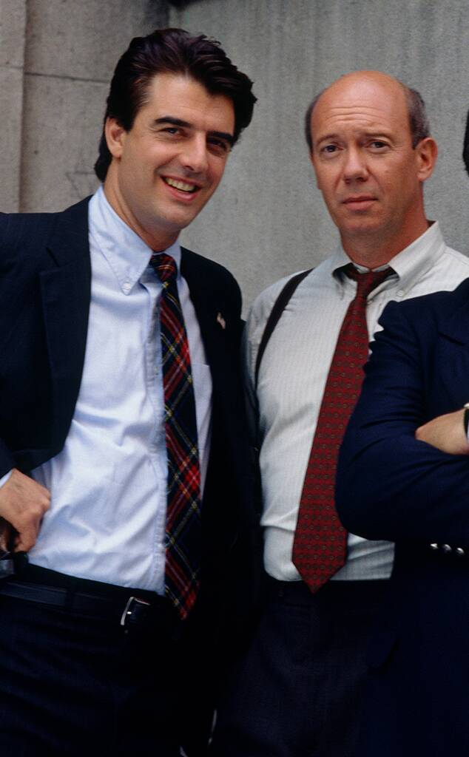NBCU Photo Bank

**Street Justice**

In 2004, a road leading to frequent filming spot Pier 62 at Chelsea Piers was rechristened *Law & Order* Way. By then, production on the show was injecting about $1 million a week into the NYC economy.

"Nobody was down there then [when the show first started]," Florek [**recalled for PeopleTV**](https://www.youtube.com/watch?v=rQlcfzttjU4) in 2015, "and my buddy Chris Noth and I used to take the golf carts and go drive all the way around there—and discover all kinds of interesting crimes." He added, "We actually would go hunting for vermin. We found, and we conquered."

Gerry Goodstein/NBCU Photo Bank

**"Hey, You Know, That Show!"**

**Carolyn McCormick**, who had a recurring role as psychologist Dr. Elizabeth Olivet (that continued on *SVU* through 2018), [**remembered to PeopleTV**](https://www.youtube.com/watch?v=rQlcfzttjU4) in 2015 getting the call back in 1991 that she had the job—and how she had to explain to her husband what the show was "because no one had ever heard of it, of course." They were at their home in New Paltz, N.Y., and they were under a newly planted baby willow tree.

So her husband said, "'Oh, that's great, that's great.' And the other day," McCormick added, "we're sitting out on our terrace looking down at this willow tree that is now, like, five stories high."

[by Taboola](https://popup.taboola.com/en/?template=colorbox&utm_source=eonline-eonline&utm_medium=referral&utm_content=thumbs-feed-01-mid-article-v2:Mid%20Article%20Thumbnail%201x1%20Vertical%20Gallery%20Widget%207:)

[Sponsored](https://popup.taboola.com/en/?template=colorbox&utm_source=eonline-eonline&utm_medium=referral&utm_content=thumbs-feed-01-mid-article-v2:Mid%20Article%20Thumbnail%201x1%20Vertical%20Gallery%20Widget%207:)

[**Famosos que são parentes e a maioria das pessoas não sabe!Vida Brilhante**](https://www.vidabrilhante.com/famosos/famosos-que-sao-parentes-e-voce-nao-tinha-ideia/?utm_source=tb&utm_medium=eonline-eonline-tb&utm_term=Famosos+que+s%C3%A3o+parentes+e+a+maioria+das+pessoas+n%C3%A3o+sabe%21-https%3A%2F%2Fs3.amazonaws.com%2Fhivemedia-images%2Fcreatives%2Fren%2Fren2.jpg&utm_content=2929959269&utm_campaign=6379601-tb&utm_source=tb)

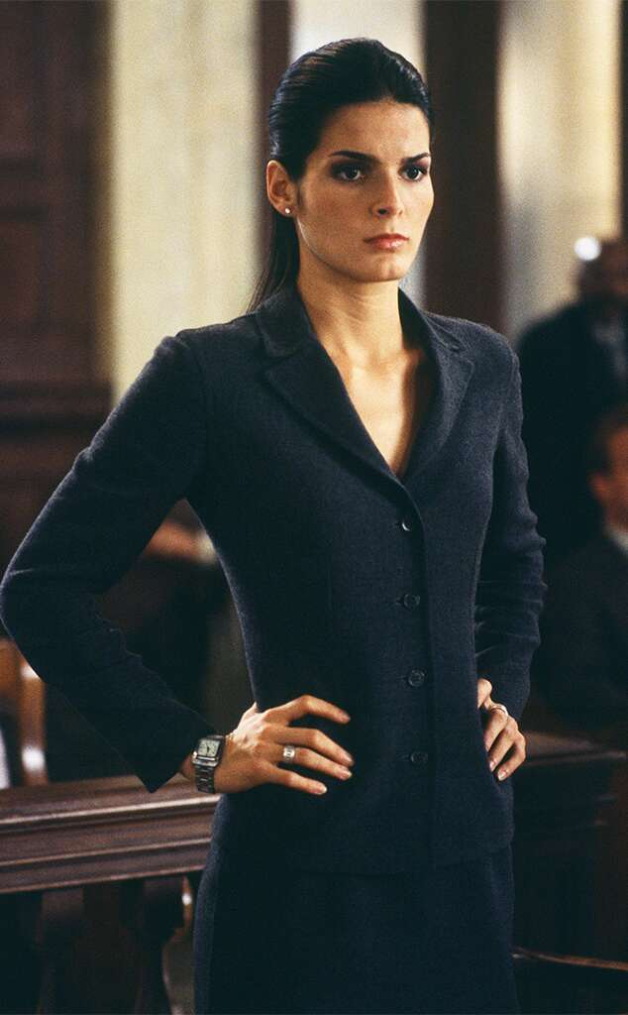Jessica Burstein/NBCU Photo Bank

**Life Isn't a Beach for Prosecutors**

[***Texas Monthly* reported**](https://www.texasmonthly.com/articles/angie-harmon/) in 2000 that Dallas native and former *Baywatch* star Angie Harmon, who had joined *Law & Order* in 1998 to play ADA Abbie Carmichael (beating out dozens of other actresses for the part), had been in the running to star in the big-screen adaptation of *Charlie's Angels*—and would have been offered the role that eventually went to **Lucy Liu** if her contract had allowed her the time to go make the movie. "I've had to really fight to prove myself, to show others that I could act, to get a chance to audition for the best roles," Harmon told the publication. "But there's a part of me that enjoys the pressure. You confront the pressure, wrestle it, and then make it work for you."

Sam Waterston told *Texas Monthly* about his co-star, "She brings a whole new energy to the show."

Once again, Wolf was right and skeptics who perhaps thought the former model didn't have the acting chops were wrong. "A: She has raw intelligence," the executive producer said. "B: She's not bad to look at. And C: She's the first cast member to have an authentic regional accent."

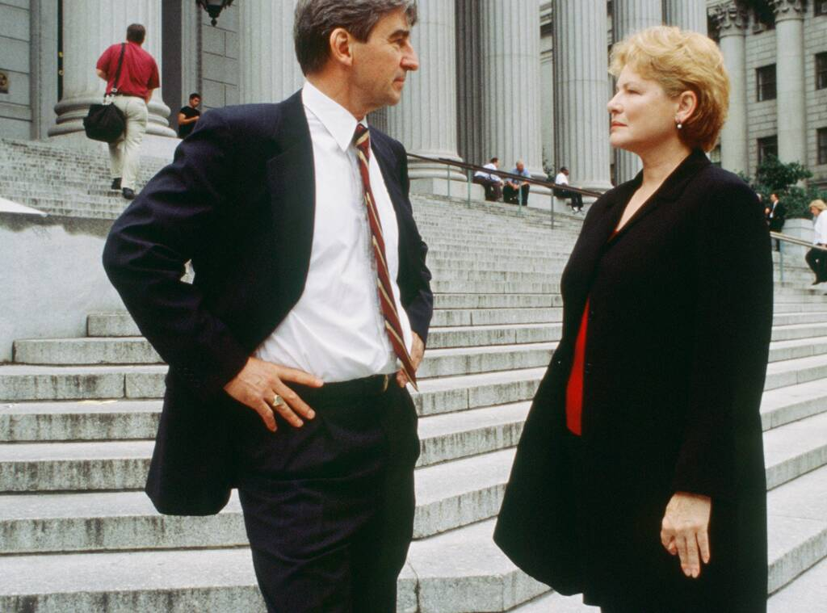Jessica Burstein/NBCU Photo Bank

**Legal Brief**

Though **Dianne Wiest** has never not been good in something, the two-time Oscar winner doesn't think much of her performance as D.A. Nora Lewin from 2000 to 2002. It was close to home for the longtime New Yorker but other than that… "It was a great show but not the type of thing I'm any good at," she [**told the *Kansas City Star***](https://www.kansascity.com/entertainment/tv/article113135168.html) in 2016. "I was really bad. I was just totally miserable and asked to leave, and they were happy to get rid of me."

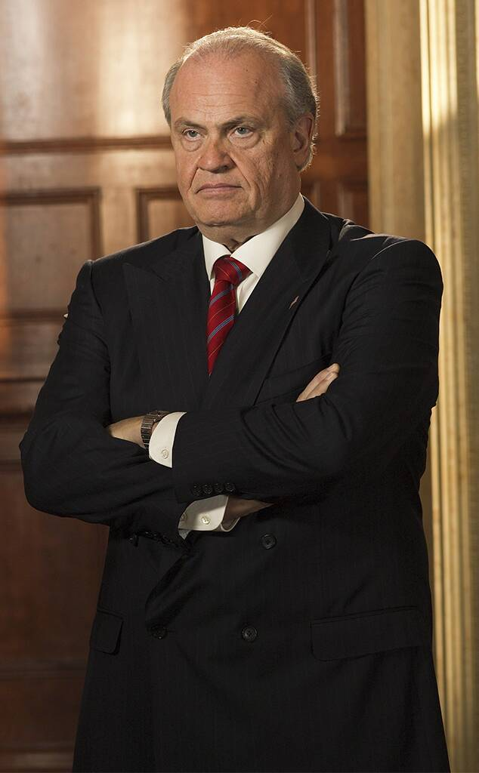Paul Drinkwater/NBCU PhotoBank

**The DA From D.C.**

Lawyer-turned-actor-turned-politician-and-back-again **Fred Dalton Thompson** was still serving out the final months of his term in the U.S. Senate, where he had represented Tennessee since 1994, when he joined *Law & Order* as District Attorney Arthur Branch in 2002, staying for five seasons.

[by Taboola](https://popup.taboola.com/en/?template=colorbox&utm_source=eonline-eonline&utm_medium=referral&utm_content=thumbs-feed-01-mid-article-v2:Mid%20Article%20Thumbnail%201x1%20Vertical%20Gallery%20Widget%208:)

[Sponsored](https://popup.taboola.com/en/?template=colorbox&utm_source=eonline-eonline&utm_medium=referral&utm_content=thumbs-feed-01-mid-article-v2:Mid%20Article%20Thumbnail%201x1%20Vertical%20Gallery%20Widget%208:)

[**Top 20 dos carros mais econômicos para rodar na estradaFicar Bonita**](https://br.ficarbonita.com/automoveis/top-20-dos-carros-mais-economicos-para-rodar-na-estrada/?utm_source=TaboolaBrasil3413190BrandDesktopFBR100CarrosEconomicos&utm_medium=eonline-eonline&utm_campaign=Top+20+dos+carros+mais+econ%C3%B4micos+para+rodar+na+estrada&utm_term=http%3A%2F%2Fcdn.taboola.com%2Flibtrc%2Fstatic%2Fthumbnails%2Fc44a2dd6e9c0640548b149ad2c36d673.jpg#tblciGiBHeQG4zAqUVOo8tj4Ps8qtomul9ST0mpidxEr49RzSmCD440k)

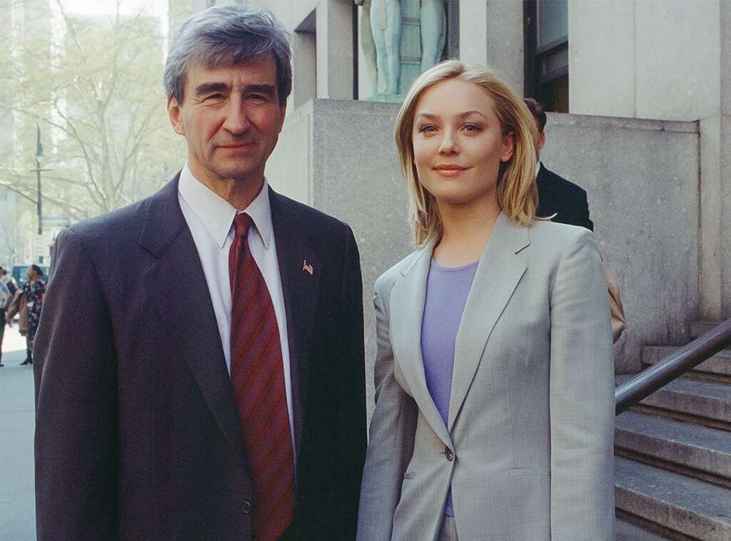Jessica Burstein/NBCU Photo Bank

**What You See Is What You Get**

**Elisabeth Röhm**, who played A.D.A. Serena Southerlyn for three and a half seasons, said she felt her altruistic, at times a little naïve (but still sharp) character reflected her own values. "In my heart there's this belief that people are good, not that people who do bad things aren't bad, but that the spirit of human beings in general—that there's hope for us," the actress told the [***Long Island Weekly***](https://longislandweekly.com/elisabeth-rohm/) in May. "I think that Serena had that idealism and I do too."

The idealism, at least, may have been her undoing, Branch disagreeing with Southerlyn's approach to a case and firing her. To which her memorable reply, out of nowhere, was "Is this because I'm a lesbian?" The answer was no, but it was a head-scratcher because Serena's personal life had never come up. (It ranked 25th on TV Land's Top 100 Most Unexpected Moments in TV History.)

Let's just say, Röhm's time on set ("my colleagues were Jerry Orbach and Sam Waterston, I mean, those are real actors") sounds more enjoyable than Southerlyn's time in the DA's Office.

"On my last day of work, Sam Waterston wrote a speech," recalled Röhm, whose recent work includes *Jane the Virgin* and *Bombshell*. "He said, I came into *Law & Order* with a 'blow torch of happiness,' and I have a child-like enthusiasm for life. I like to have fun. I like to treat people kindly. I want to make an impact. I want to make a difference."

She continued, "And I think that I do have that child-like enthusiasm and idealism, and belief in humanity. I'm never surprised when people are kind because I know inside of us is all this hope and desire to evolve and to be happy. That doesn't mean that there aren't criminal minds, degradation, despair, poverty and violence."

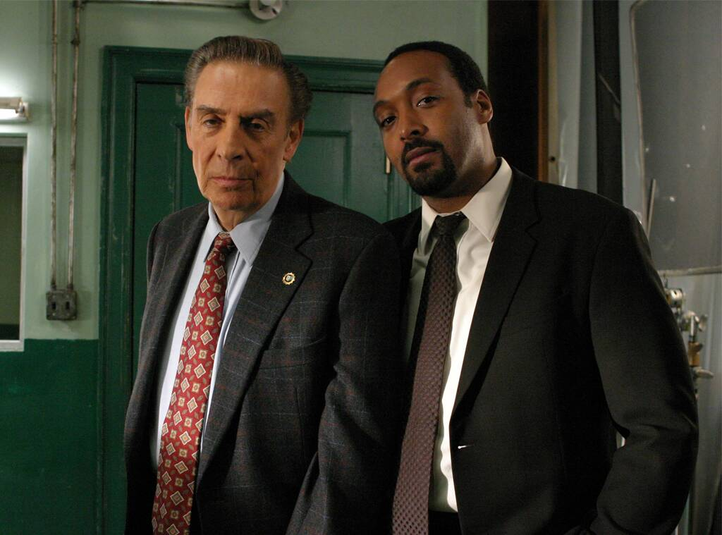NBCU Photo Bank

**Green Streets**

After nine seasons, **Jesse L. Martin** decided he had had a good run as Detective Ed Green—and though he was done walking the beat, he wanted Green to keep running.

"I don't wanna die, to be honest," the actor, whose other iconic claim to fame was originating the role of Collins in *Rent*, [**told EW.com**](https://ew.com/article/2008/02/21/jesse-martin-on/) in February 2008 as his final episode approached. "I really don't. I don't wanna die. I like the possibility of maybe returning for some reason. It'd be nice to have, like, a mysterious exit. But of course, none of this is up to me. They can end it the way they see fit."

Asked if he'd have any input on his character's fate, he said, "I don't know. I mean, I'm sure they'll listen to me, but ultimately, it's their show. They can make it do what it wants to do. I just hope it's a cool exit. I really do."

Well, Green lives! He turned in his badge after shooting a gambler and, despite being cleared by Internal Affairs (an investigation led by Martin's incoming replacement, **Anthony Anderson**'s Detective Kevin Bernard), he decides it's time to go. They did not end up finding a reason for him to return, but Martin moved on, and is now a star of *The Flash* on CW.

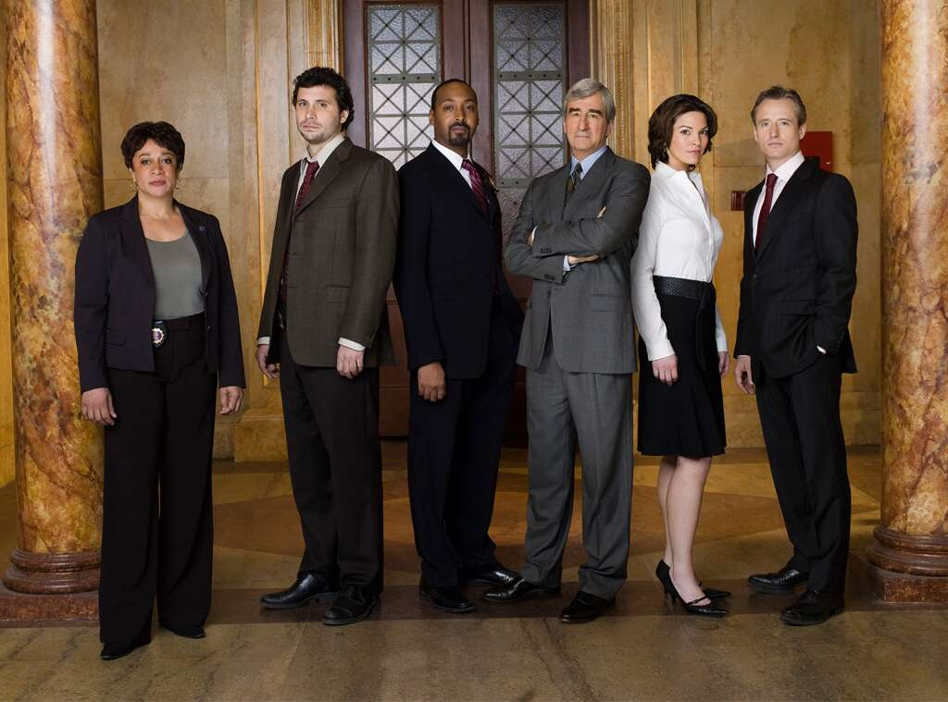Virginia Sherwood/NBC/NBCU Photo Bank

**Ripped From the Headlines**

The stories may have been fiction, but sometimes the gas was real.

"I don't know what I had for lunch that day, but I had the bubble guts," **Anthony Anderson**, who played Det. Kevin Bernard for the show's final three seasons, shared on *Late Night With Seth Meyers* in 2016. "I was holding it in this entire scene, like a five-minute scene, and I held it in. And as I left the room, I left something in the room. And **Jeremy Sisto** was coming in to do his part of the scene—this was all on camera—and you could see S. Epatha Merkerson [making a "what's that smell?" face], and it started to just burn! And she was like, 'Wait a minute, wait a minute! Cut! Which one of y'all motherf--kers farted?! That is some nasty s--t, which one of you motherf--kers did this?!'"

Anderson continued, turning to the camera, "So, S. Epatha Merkerson, Jeremy Sisto, I would like to apologize to you both; one, Epatha, for letting that go in the scene, and Jeremy, for letting and allowing you to take the blame for that." He noted that Sisto "was a stand-up partner, he did not snitch."

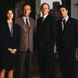

[**PHOTOS**](https://www.eonline.com/photos/31440/secrets-of-law-order/page/2/#31)

[**View More Photos From 30 Secrets About *Law & Order***](https://www.eonline.com/photos/31440/secrets-of-law-order/page/2/#31)

"I think it's the writing, really," **S. Epatha Merkerson** said, musing on the true reason for the series' marathon run, supplemented by actual marathons, on *Today* in 2015. "The scripts were always so incredibly well-written and also people had an investment because they were taken from the headlines, so you already knew the story but what you watched for was how the twist would happen at the end."

And yes, at the time Wolf wished the flagship series was still chugging along, since the world hadn't exactly run out of the fuel that fired *Law & Order*'s stories.

Asked if he could revive anything he had previously worked on, he told [***The Hollywood Reporter***](https://www.hollywoodreporter.com/news/tv-producer-year-dick-wolf-794537) in 2015, "Oh, I'd bring *back Law & Order*. Everybody who knows me knows it's something I want to do. My only regret looking backward is all the great stories that we haven't been able to do for the past five years. It feels like there's something every day. I would have loved us to have found a way to do [the private military company] Blackwater. And then [**Robert**] **Durst**, obviously."

But at least there was plenty of fodder for his—and so many people's—nightly ritual.

"I'll watch anything, but there's little I'm addicted to except for [*The Tonight Show Starring*] **Jimmy Fallon**," he said. "That's must-watch for me. And then I usually go to USA or TNT and fall asleep to *Law & Order*."

*Law & Order* seasons 13 through 20 are currently [**streaming on Peacock**](https://www.peacocktv.com/).

(E!, NBC and Peacock are all members of the NBCUniversal family.)